**Connect PowerShell to your Windows Azure subscription**

After downloading and installing the Windows Azure PowerShell module, you need to perform the following initial steps from Windows PowerShell to configure connection information for your Windows Azure subscription. After you perform these steps the first time, the configuration is saved locally, and you do not need to perform these steps again.

1. Set the Windows PowerShell script execution policy to **RemoteSigned**:

Set-ExecutionPolicy -ExecutionPolicy RemoteSigned

2. Import the Windows Azure PowerShell module:

Import-Module Azure

3. Download the Windows Azure Publish Settings file for your Windows Azure subscription. When you run this cmdlet, a web browser launches and asks you to sign in. Sign in with the same user name and password credentials that you used when you activated your Windows Azure subscription.

Get-AzurePublishSettingsFile

**Note**When you save your Publish Settings file, specify a short easily-typed file name to save your file. You need to type the complete path to this file name in the next step.

4. Import the downloaded Windows Azure Publish Settings file into your Windows PowerShell environment. This updates your Windows PowerShell environment with the connection and certificate information that is needed to connect and authenticate to your Windows Azure subscription.

Import-AzurePublishSettingsFile -PublishSettingsFile "full path to downloaded file"

**Note** After you import the downloaded Publish Settings file, store it in a secure location. The Publish Settings file contains certificate information that can be used to authenticate to your Windows Azure subscription, and as such, it should be treated with the same security precautions that you normally observe for storing administrative credentials.

After you complete the steps in this section, Windows PowerShell is configured to connect to your Windows Azure subscription. To test this connection, enter the following cmdlet to connect to Windows Azure and enumerate your subscription information:

Get-AzureSubscription

[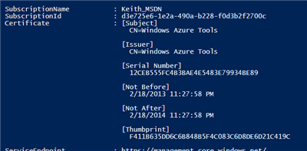](http://blogs.technet.com/cfs-file.ashx/__key/communityserver-blogs-components-weblogfiles/00-00-00-76-18/6661.wes_2D00_6_2D00_22_2D00_13_2D00_3.png)

Success! The Windows Azure subscription results from the **Get-AzureSubscription** cmdlet.

Select the subscription to use:

Select-AzureSubscription -SubscriptionName "mysubscription"

Resources:

<http://blogs.technet.com/b/heyscriptingguy/archive/2013/06/22/weekend-scripter-getting-started-with-windows-azure-and-powershell.aspx>

<http://michaelwasham.com/windows-azure-powershell-reference-guide/getting-started-with-windows-azure-powershell/>

<http://blogs.technet.com/b/keithmayer/archive/2014/04/06/step-by-step-getting-started-with-windows-azure-automation.aspx>